4/6 - Today I did a basic creation of the schematic of the VCO. I’m worried about how to simulate it and I will likely need to go through and insert all the part numbers. I need to find these on a website to source all of them from. Make 100% sure everything matches.

Next Steps: Formulate some questions for Robert (peer reviewer) about simulating

4/7 - Today I redid the circuit by remodeling the components to spice models that way I can simulate it. Tomorrow I should look into actually simulating it which might require looking into those youtube videos a lot more so I understand what to test.

4/9 - I’m pretty stuck on simulating the reverse sawtooth oscillator core. I can’t figure out how to get the inverter to oscillate. Tomorrow you should look into downloading the CD40106 model onto LTspice and get it to actually work.

4/10 - I got the basic spice simulation working for the oscillator core. I also did some research into sourcing the parts for the PCB. I need to make sure Robert checks these. Tomorrow I will finish sourcing these parts and maybe look into simulating the whole circuit just to verifying I didn’t mess up routing.

4/11 - I need to find a way to put the 10 pin male connector on the PCB. I was also thinking that I need to spend significantly more time understanding the circuit I am creating. That way I learn more and get more confidence with the creation. There is also the idea of adding some sort of difference between my design and the mortiz klein one. Change capacitor footprint.

4/12 - Does the pin which is negative 12 matter vs positive 12 when it comes to plugging in the power supply? My guess is no.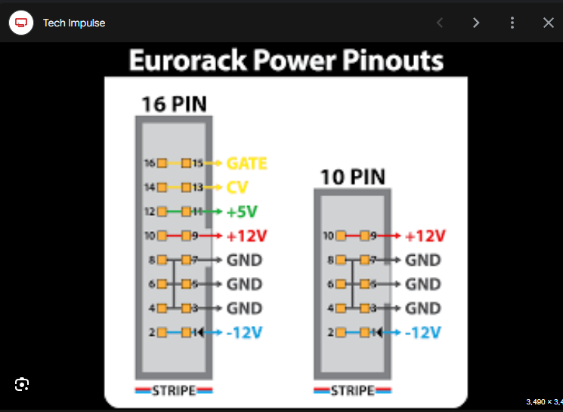

<https://www.google.com/search?sca_esv=4b8f7db787efb9d9&rlz=1C1ONGR_enUS1061US1061&sxsrf=ACQVn09lpqhmZvOMKeFI_kRW0Z-R4KwwNw:1712977293675&q=%CE%BCZEUS+pinout&uds=AMwkrPuhn_F0WDJCwQwE6XxpOj7eCjqBy9JlkUtLK8UHBs7pjf1fJgYnlU0g8j3vr36OyBk24RNN0sDV7_sXR_Z-nLoCDCLEYXL4igroH8R5wEPYZ6xojnYWbdvHZgm2Ct684eEe_grfpSGpb45XXqWQTC4xmZ2OCrhpkQVt-PBvREZ30RL6_snDCjMS-aetn_z7oGX4CjToBxkOL1fkobe_qGDLgH9Yf_dFyspC1cwsvP6A98KzZIBlN6ZxNBNKZBPDlrGT5Iu-8AbvIWB_5d6nI-duvUamZQhT4TigJ015hBvlRzA_44qzocBpKBXGM0ZiqUKXBxnT&udm=2&prmd=isvnmbtz&sa=X&ved=2ahUKEwif5ePYmb6FAxWfHjQIHQEXC5AQtKgLegQICxAB&biw=1920&bih=945&dpr=1#imgrc=b3LAZzvrGAiN9M&imgdii=P_U5uJMzVHLADM>

4/14 - I spent some time today just understanding PCB design stuff and watching videos on it. I am torn about whether I want to go through and simulate the entirety of the design to better understand it. If I do choose to go down that route it will likely take up the next month of my time and I’m being lazy by not wanting to do that. So, let's discuss what my process should be. I like the idea of potentially building the circuit alongside the designs and testing each phase incrementally to understand the entirety of the circuit step by step. So I guess my next step now would be to model the voltage controlled resistor with the BJTs.

4/18 - Should I have both a +12V and -12V plane? Some pins on PCB have no lines referencing where they should be routed to is this do I route them to the correct reference anyway? Should I wire together all +12, -12, GND references on PSU 10 pin connector?

4/19 - route tp on top and bottom

4/21 -

* there needs to be a copper pour on the same layer as the traces, so you dont have large amounts of empty space. The manufacturer may have to leave it in the etch longer to make larger areas dissolve, though this isn't much of a problem in modern pcb manufacturing. you should make this a ground layer, and add test points to it on the outside, so that you can have many easy access points to ground when probing for testing. you can even buy test point clip parts. one we like is 5001 from keystone.

Currently having a problem with the DRC related to the ground holes in the corners.

4/23 - still having the problem with creating mounting holes. I’m also now concerned with the PSU. I did not realize it would be $80 so now I’m considering powering the whole system with 2 9 volt batteries or a bench power supply ~$50. For now I will just use the power supplies in the tectronics lab.

4/24 - currently in the process of simulating everything from the youtube videos.

4/28 - I need to go into the techtronics lab to breadboard and test the circuit.

VCO - voltage controlled oscillator.

Needs to be tuned with a pitch knob

This seems to be the basis of all oscillation in a synth. Here is the basic design of a sawtooth oscillator: 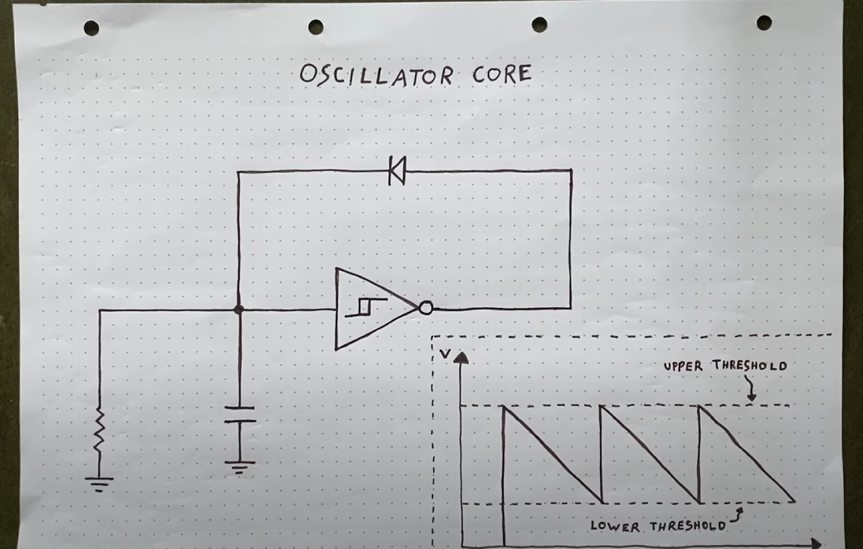

The capacitor rate of discharge through the parallel resistor is what determines the frequency of the output wave.

Capacitor size: as it raises the frequency lowers

Not useful since it changes the shape of the wave since the charge of the capacitor isn’t instant and takes a non-zero amount of time.

Resistor Value: as it raises the frequency lowers

Use a NPN bipolar junction transistor - ability to open to different degrees.

We need the resistance value to increase exponentially because that is how notes work with frequency.

VCF - voltage controlled filter

Low pass type thing

VCA - voltage controlled amplifier

Uses an envelope generator or LFO as input

LFO - low frequency oscillator